When you open the website Ansight there is a gap between Turn Location data into decisions or is it the way it should be? The Explore capabilities and all other buttons have been highlighted in blue and the discuss a project is not highlighted BY DEFAULT WHAT ARE WE DOING?
ALSO CAN WE REMOVE ALL THE FULL STOPS IN THE HEADERS
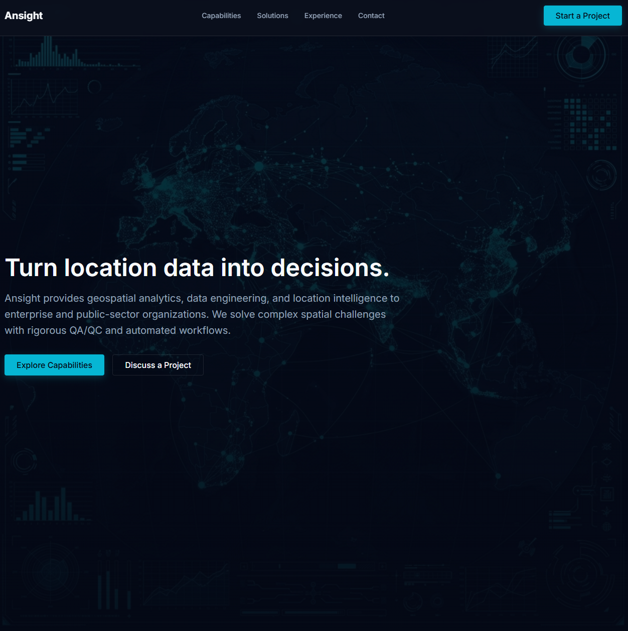

Can the capabilities section be more thought out it looks weird why list AWS, ESRI, TSU AND HAZEN &SAWYER. IT SHOULD BE REMOVED.

CAPABILITIES: WHAT IS THIS SPACE CAN WE MAKE THIS SECTION MORE LIKE EACH OF THE CAPABILITIES ARE IN THEIR OWN BOX ALTERNATED
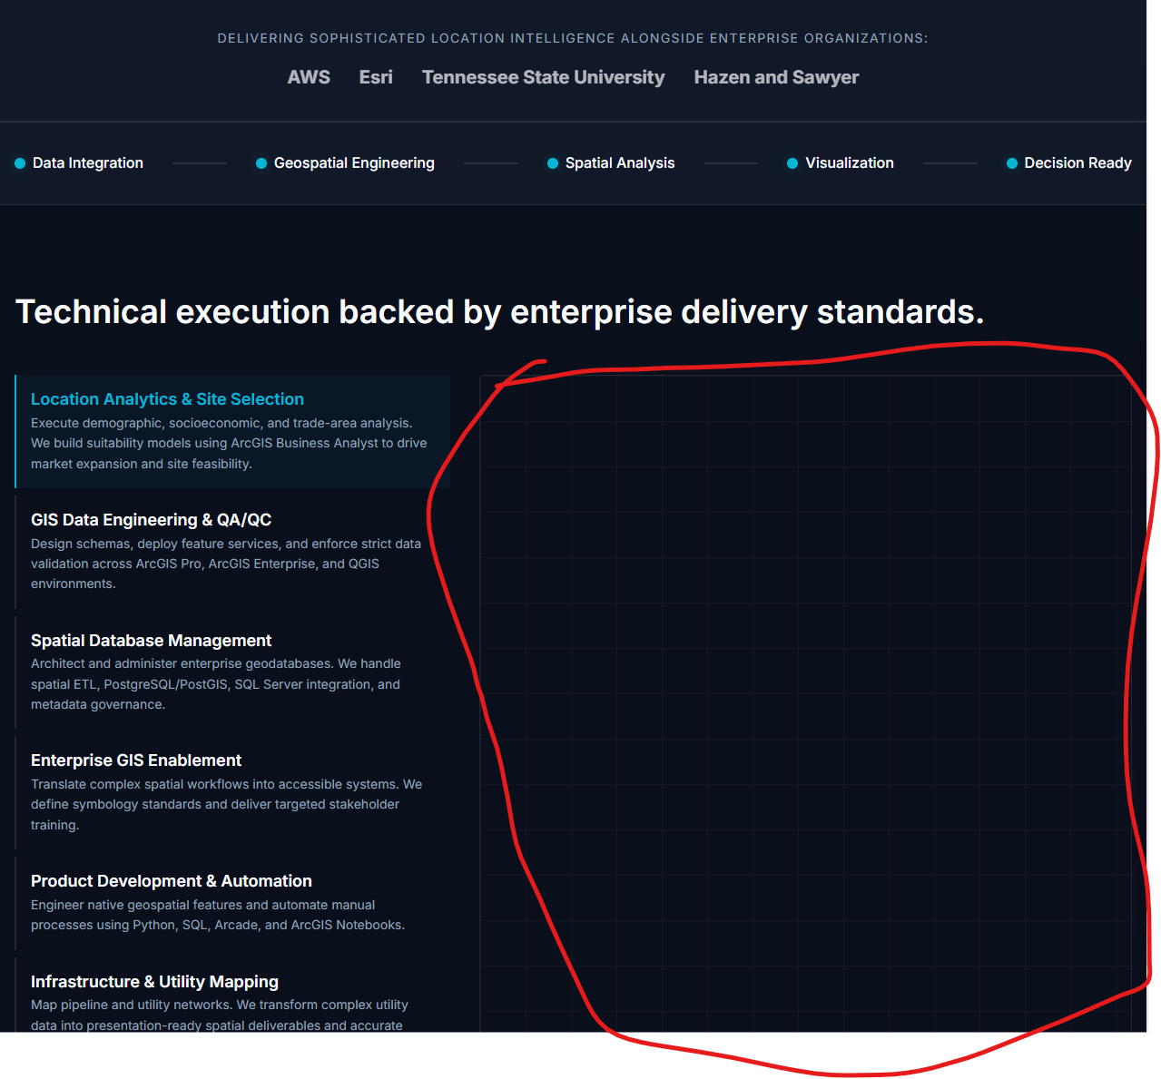

SOLUTIONS: CAN WE REDESIGN THIS BIT AND REMOVE THE EMPTY BOX CAN WE MAKE THE HEADER OF THIS SECTION MORE INTUITUITIVE WITHOUT THAT FULLSTOP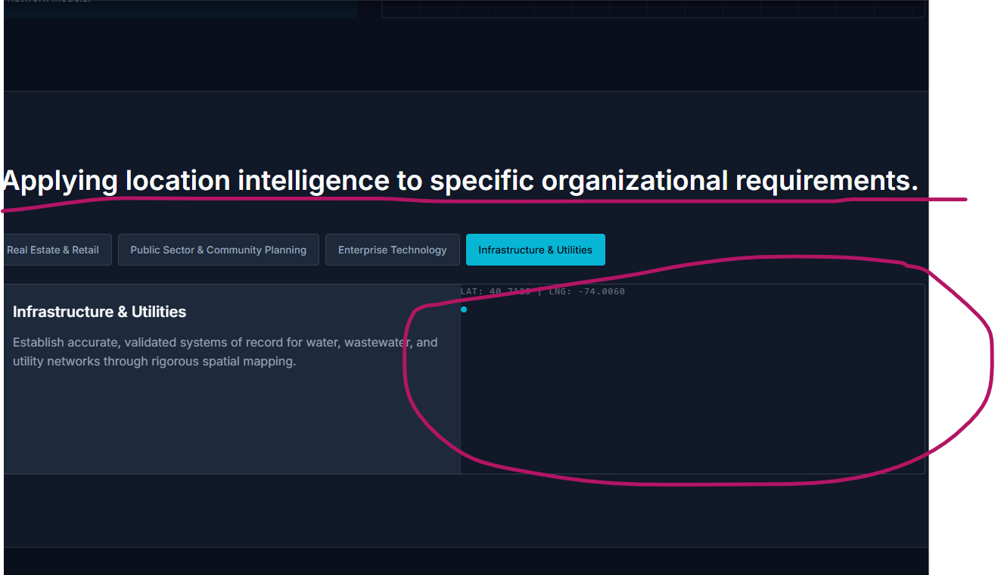

Rewrite the experience section without adding the name of the the companies make it more intuitive, remove all the empty spacesa.
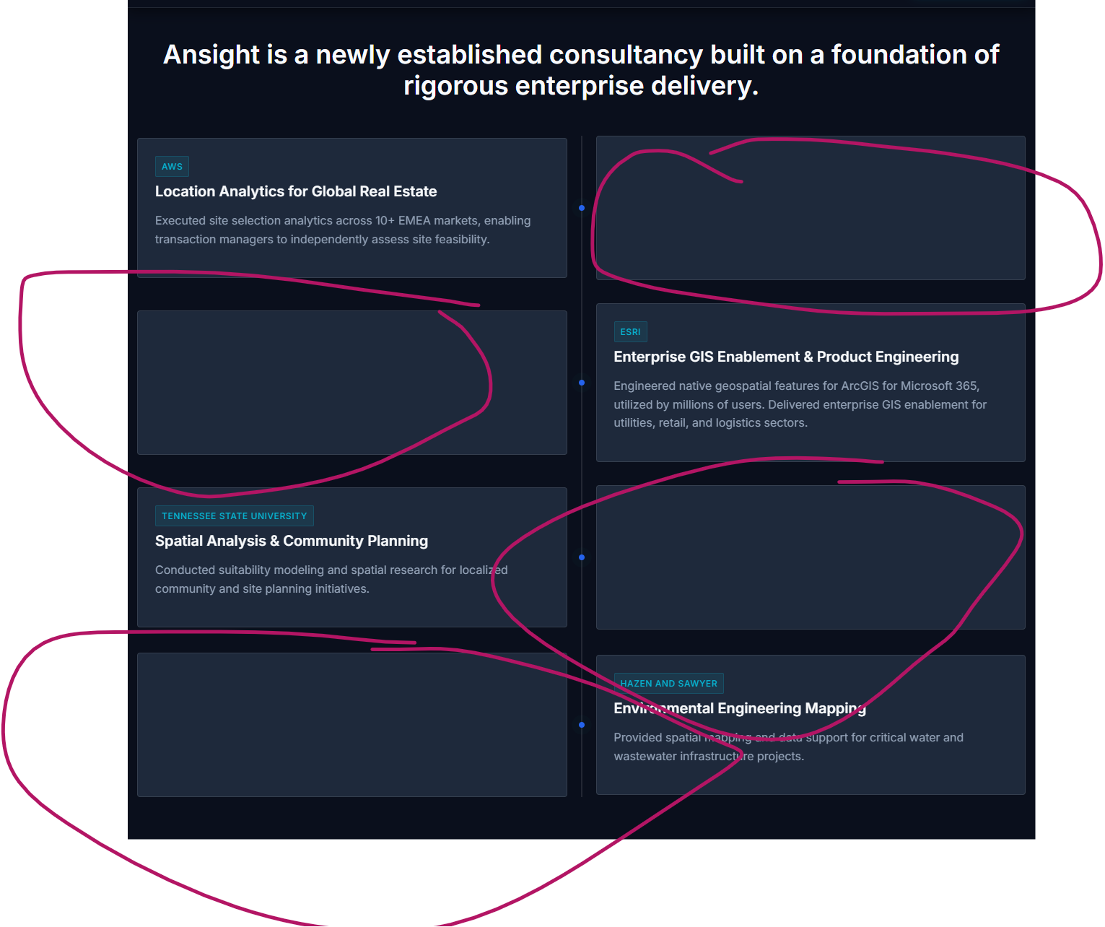

The Contact US BUTTON
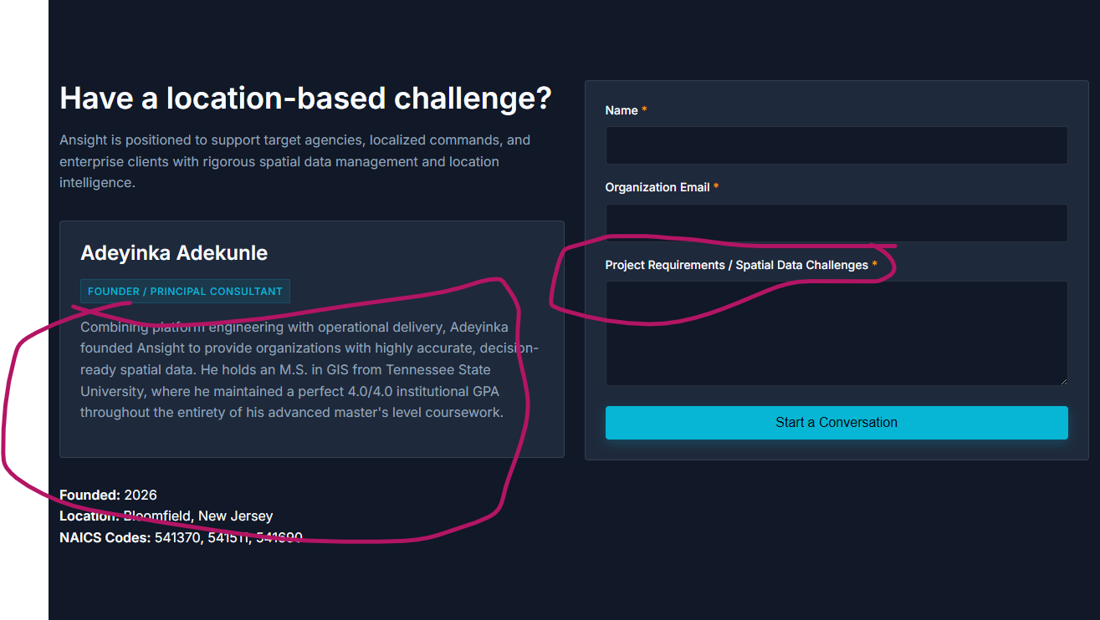
Adeyinka Adekunle is a lady, I mean the principal. Remove GPA. THIS IS A PROPER COMPANY MAKE IT A STELLAR CONTACT US SECTION
REMOVE THE NAICS CODES
ADD MY DETAILS IN A GOD ORDER
Adeyinka Adekunle
Principal | Ansight
GIS Consulting & Location Intelligence
adeyinka@ansightco.com
+19735671317
www.ansightco.com
https://www.linkedin.com/in/adeyinka-adekunle-37162a155/

